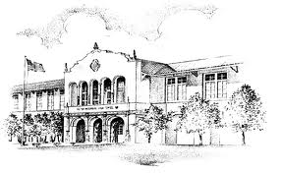 **JOIN THE PTSA   
 (Parent, Teacher, Student Association)**

SPHS

**AND *MAKE A DIFFERENCE***

***WHY BECOME A MEMBER?***

*Get To know SPHS teachers, staff members and principal.*

*Get informed about your child’s school and provide your input.*

*Create positive change and have a voice in your child’s education.*

HOW DO I BECOME A MEMBER OF THE

PTSA AT ST. PETE HIGH SCHOOL?

Join on line at: <https://stpetehigh.memberhub.com/store?limit=21&live=true>

* Membership Dues: Parents, $15 Teachers $10.00 and Students are $5.00
* **OR** fill out the form below and bring to the front office (room 101)
* **OR** mail the form below with a check or cash to: **SPHS PTSA, 2501 Fifth Avenue North, St. Petersburg, FL  33713**

**-------------------------------------------------------------------------------------------------------------------**

Parent or Teacher Name: ____________________________________________________________________

Student name: _______________________________________________________ Grade: __________

Mailing Address: ___________________________________________________________________________

Contact Phone(s): __________________________________________________________________________

E-Mail Address(es): _________________________________________________________________________

Membership Dues: (Parents - $15.00, Teachers $10.00 Students - $5.00) ____________________________

Please list any areas of expertise or skills you are willing to share with PTSA ______________________________